**Building Your First ARIMA Model**

**Step 1 - Check stationarity:** First thing to do is to visualize the data with a *TS Plot*. Connect a browse tool to the **I** output node and take a look at the output. You can see some seasonality and perhaps some trend as well.

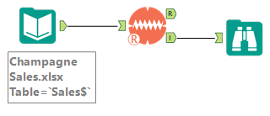

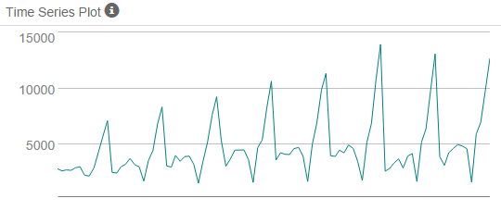

**Step 2 - Difference:** Let's start with a seasonal difference and observe the resulting plot. To take the seasonal difference, you use a *Multi-Row Formula* tool and use the formula **[Champagne Sales] - [Row-12:Champagne Sales]**. Attach a browse tool and look at the plot. It looks like the seasonal differencing was enough to make the time series stationary!

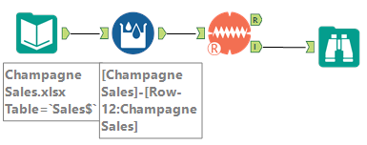

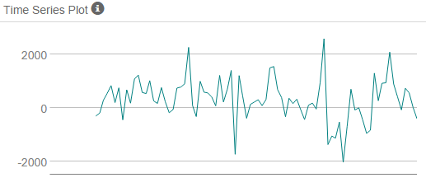

**Step 3 - Filter out a validation sample:** This is done the same was it was done with the ETS model. Attach a *Record ID* and *Filter* tools to the *Data Input* tool and filter out the last 6 periods.

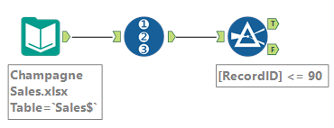

**Step 4 - Select AR and MA terms:** Let's take a look at the ACF and PACF of the seasonally differenced dataset. There appears to be significant positive autocorrelation at periods 1 and 13. The positive autocorrelation points towards AR terms, so I'd suggest starting with one AR term for both the seasonal and non-seasonal parts of the ARIMA model for:

**ARIMA(1,0,0)(1,1,0)12**

Remember, selecting these terms manually generally means choosing several models and comparing them against a validation sample. In our case, we'll just build out one manual model for practice, then use the auto settings to have the tool choose the best model for us.

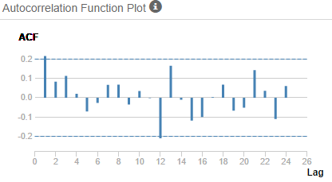

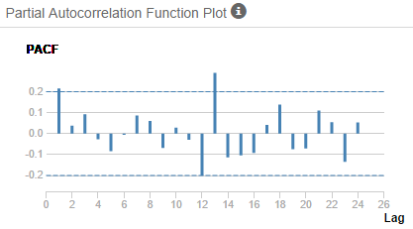

**Step 5 - Build the model:** Build the model using the *ARIMA* tool and set the number of periods to forecast to 6. Attach a browse tool to the **I** output node. After running the model, you can see the forecast of the last six periods. The forecast of the final period is 13,366.

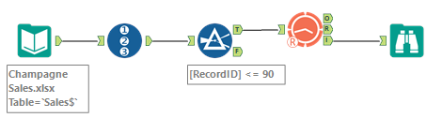

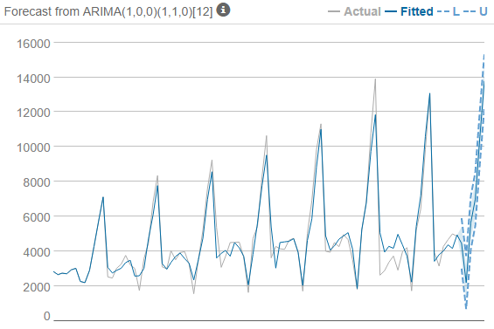

**Step 6 - Validate model:** Compare the predicted values to the actuals in the validation sample using the *TS Compare* tool. For the final period, the ARIMA model forecasted 13,366 vs the actual of 12,670.

